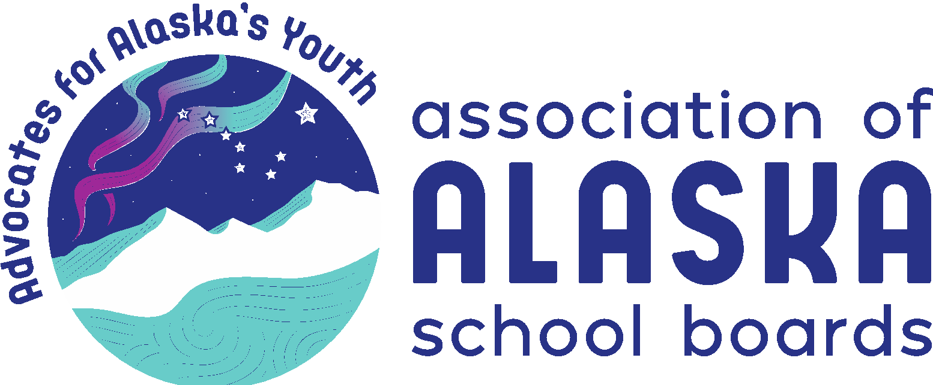
AASB Legislative Priorities

2021

The AASB Board of Directors has chosen the following priorities for its 2021 legislative advocacy focus. Supporting resolutions of the membership can be found in the document Where We Stand 2021 on the AASB website.

Public Education Funding – adequate, reliable, predictable
- Adequate – Prevent the devastating impacts of the pandemic to school funding in 2021 and 2022 due to temporary reductions in adjusted ADM
- Finding must be reliable and stable, predictable
- Uphold the constitutional mandate for public school funding
- Guard against the use of public funding for private schools – no vouchers
- Prevent cost shifting of items such as transportation, bond-debt reimbursement, major maintenance, and retirement to districts and local communities
- Prevent state mandated school consolidation, especially in rural Alaska

Student Wellness and Safe Schools – prioritize efforts and funding to support and promote student wellness and safety
- Address the impacts of the pandemic on student wellness (physical and mental)
- Support student mental health and the required services
- Support safe, connected schools
- Support trauma informed practices in Alaska schools
- Prevent sexual abuse by school staff through appropriate professional boundaries policy and training
- Reduce school and student violence

Internet Connectivity and Distance Delivery – provide an equitable opportunity for students across the state to access learning and content as a part of their educational experience
- Fully fund E-rate so that schools have the necessary connectivity
- Investing in Alaska broadband infrastructure for equitable access everywhere
- Alaska relevant and appropriate distance delivered curriculum and instruction
- Locally adapted and school board approved curriculum
- Provide appropriate professional development for distance delivered instruction
- Develop equity in providing distance delivered, instructional opportunities

Teacher & Administrator Training, Recruitment and Retention – through multiple approaches increase the retention, recruitment and training of highly effective teachers and administrators.
- Reduce the extremely high rates of teacher and administrator turnover
- Provide resources for a robust teacher-mentor program
- Provide and fund more competitive retirement benefits
- Invest in effective professional development of teachers and administrators
- Work with partners and the University of Alaska to improve and develop a teacher training program focused on growing teachers and administrators from Alaska

Culturally Responsive Education – provide a culturally responsive education that includes language, place, and relevance.
- Support creation of culturally responsive learning environments for all students
- Support and facilitate implementation of standards for culturally responsive schools
- Support preservation and use of indigenous Alaska Native languages
- Support and fund culturally responsive educator preparation programs
- Support and fund an authentic, and compressive Alaska History textbook
- Support creation and use of culturally appropriate student achievement assessments

Literacy as A Fundamental Human Right
- Funding and support for focus on early childhood literacy skills development
- Working towards literacy proficiency by the third grade
- Investing in higher graduation rates and a more literate populous
- Through literacy proficiency create educational equity
- Recognize literacy as a fundamental human right

The mission of the Association of Alaska School Boards is to advocate for children and youth by assisting school boards in providing quality public education, focused on student achievement, through effective local governance.

