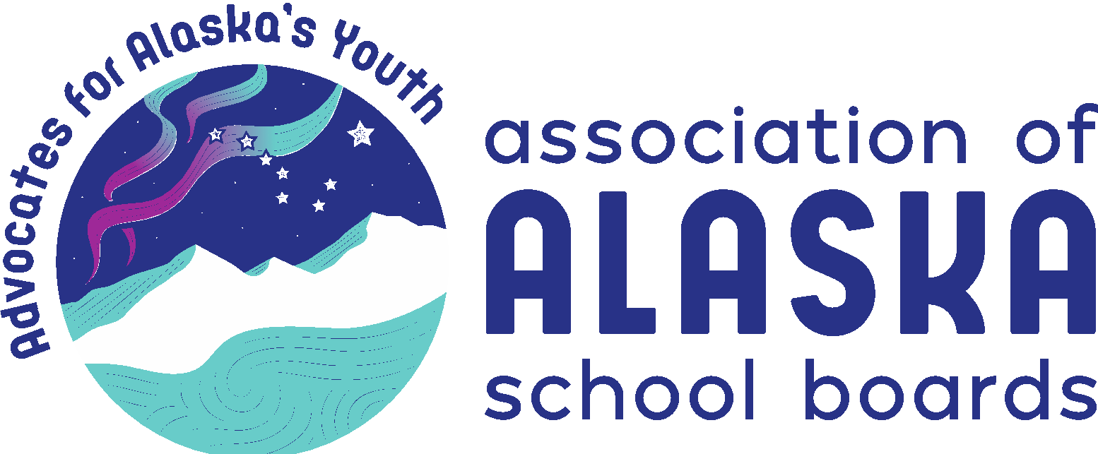
AASB Legislative Priorities 2022

The AASB Board of Directors has chosen to continue the following priorities for its 2022 legislative advocacy focus. Supporting membership resolutions can be found in the document Where We Stand 2022 on the AASB website.

Public Education Funding – adequate, reliable, predictable
Ensuring stable, sustainable, and adequate funding for public education is essential to Alaska’s long-term success and viability. A sustainable, long-term fiscal plan is imperative for Alaska to meet its constitutional responsibility and is the best hope for successfully meeting future challenges. Solve the PFD dilemma so Alaska can serve its students appropriately.
- Adequate – The Base Student Allocation (BSA) has remained the same since 2017, while inflation and labor shortages (certified, classified, and administrators) have significantly increased.
- Reliable, stable, and predictable (CS HB4003 House Ways & Means)
- Prevent cost-shifting of items such as transportation, bond-debt reimbursement, major maintenance, and retirement to districts and local communities

Literacy as A Fundamental Human Right
AASB strongly advocates prioritizing funding and programs to improve literacy skills for all Alaska students, especially early childhood literacy. This will have the single most significant impact on high school graduation and the opportunity for success with postsecondary education. (SB111 & HB164 Universal Pre-k and reading)
- Funding for early childhood literacy skills development
- Achieving literacy proficiency by the third grade
- Literacy proficiency creates educational equity
- Recognize literacy as a fundamental human right

Recruitment and Retention of Teachers & Administrators– through multiple approaches, increase the retention, recruitment, and training of highly effective teachers and administrators.
School districts across Alaska experience great difficulty retaining qualified, effective teachers, let alone attracting new candidates to vacant positions. The turnover rate is staggering in both urban and rural districts.
- Support the implementation of the recommendations from the Teacher Recruitment & Retention Task Force
- Reconfigure and fund a competitive retirement benefits program that may include both defined benefits and defined contributions.
- Support and invest in teacher housing for rural school districts.
- Support a robust teacher-mentor program
- Work with partners and the University of Alaska to improve and develop a teacher training program focused on growing teachers and administrators from Alaska

Student Wellness and Safe Schools – prioritize efforts and funding to support and promote student wellness and safety
The effects of the pandemic on student wellness have been felt by every demographic but especially by those students experiencing poverty or trauma. Violence, neglect, and sexual abuse have increased, resulting in declines of student social-emotional well-being and academic achievement.
- Support and fund student mental health services available to all Alaska’s students
- Support and fund the use of trauma engaged practices in Alaska schools
- Compel school districts to adopt and implement policies and training regarding professional boundaries between staff and students to prevent sexual abuse by school staff
- Support and fund programs and services that reduce school and student violence

Broadband and Virtual Equity – Pandemic Issues - provide an equitable opportunity for students across the state to access learning and content as a part of their educational experience
The COVID-19 pandemic brought to the forefront the significant inequities students in all school districts face. Remote, rural districts face exceptional challenges with access to adequate broadband that has led to the creation of a “homework gap” that impedes student success and learning.
- Fully fund the federal E-rate program so that schools have the necessary connectivity
- Investing in Alaska broadband infrastructure for equitable access everywhere
- Alaska relevant and appropriate, distance delivered curriculum and instruction
- Locally adapted and school board approved curriculum
- Develop equity in providing distance delivered, instructional opportunities

The mission of the Association of Alaska School Boards is to advocate for children and youth by assisting school boards in providing quality public education, focused on student achievement, through effective local governance.

