CERTIFICATE OF RECOGNITION
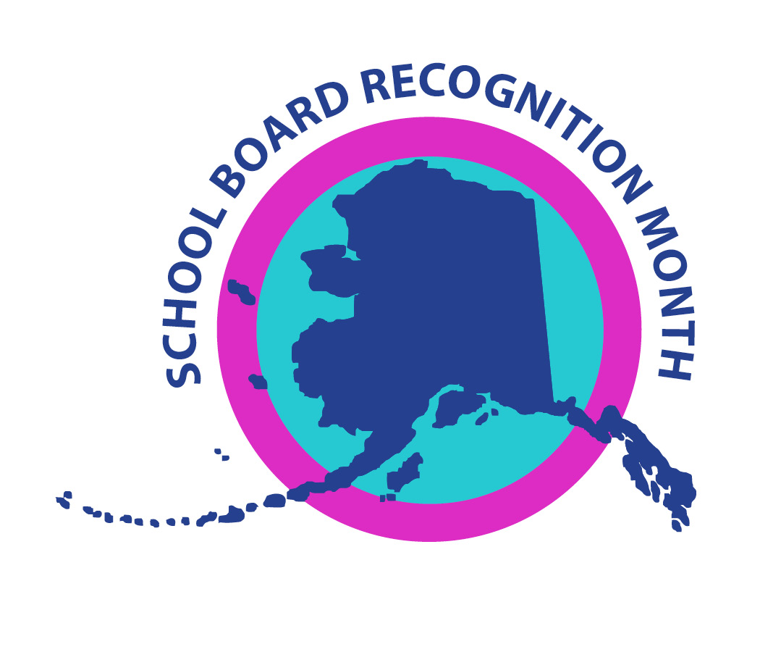

Honoring
School Board Members Name

The school district, group, or business name
joins the
Association of Alaska School Board
in recognizing February 2022 as

School Board Appreciation Month

Honoring local school board members for
their dedicated leadership in public education
and continuing service to the children of this community.

