CERTIFICATE OF RECOGNITION

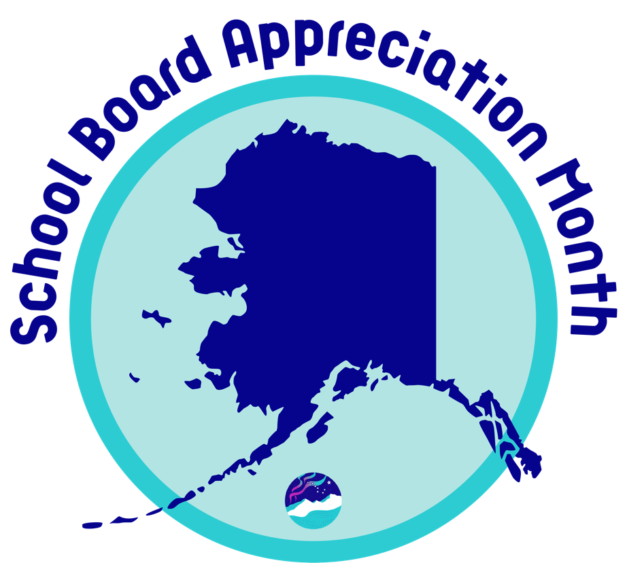

Honoring
School Board Member's Name

The school district, group, or business name
joins the Association of Alaska School Boards
in recognizing February 2023 as

School Board Appreciation Month

Honoring local School Board members for
their dedicated leadership in public education
and continuing service to the children of this community.

