FAMILY & COMMUNITY ENGAGEMENT

RESULT: Family & Communities Support Learning

Data points:
- 56% of students in STEPS schools, grades 6-12, reported that parents and community members were involved in their school
- 82% of students in STEPS schools grades 3-5, reported that adults in their community let them know school is important

What isn’t working? What gaps are there?
- Lack of communication btwn schools/orgs and families
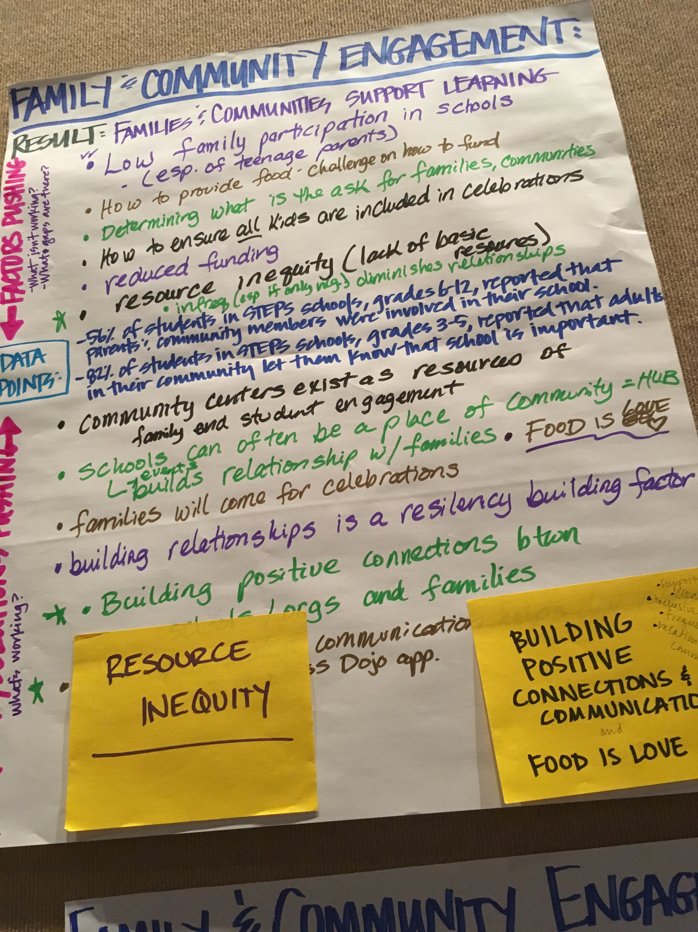
- Need to increase of family participation
- Lack of funding for food*
- Parent engagement decreases as kids grow
- Employers not support family needs & participation*
- Low family participation in schools especially of teenage parents
- How to provide food – challenge on how to fund
- Determining what is the ask for families, communities
- How to ensure all kids are included in celebrations
- Reduced funding
- Resource inequity (lack of basic resources)

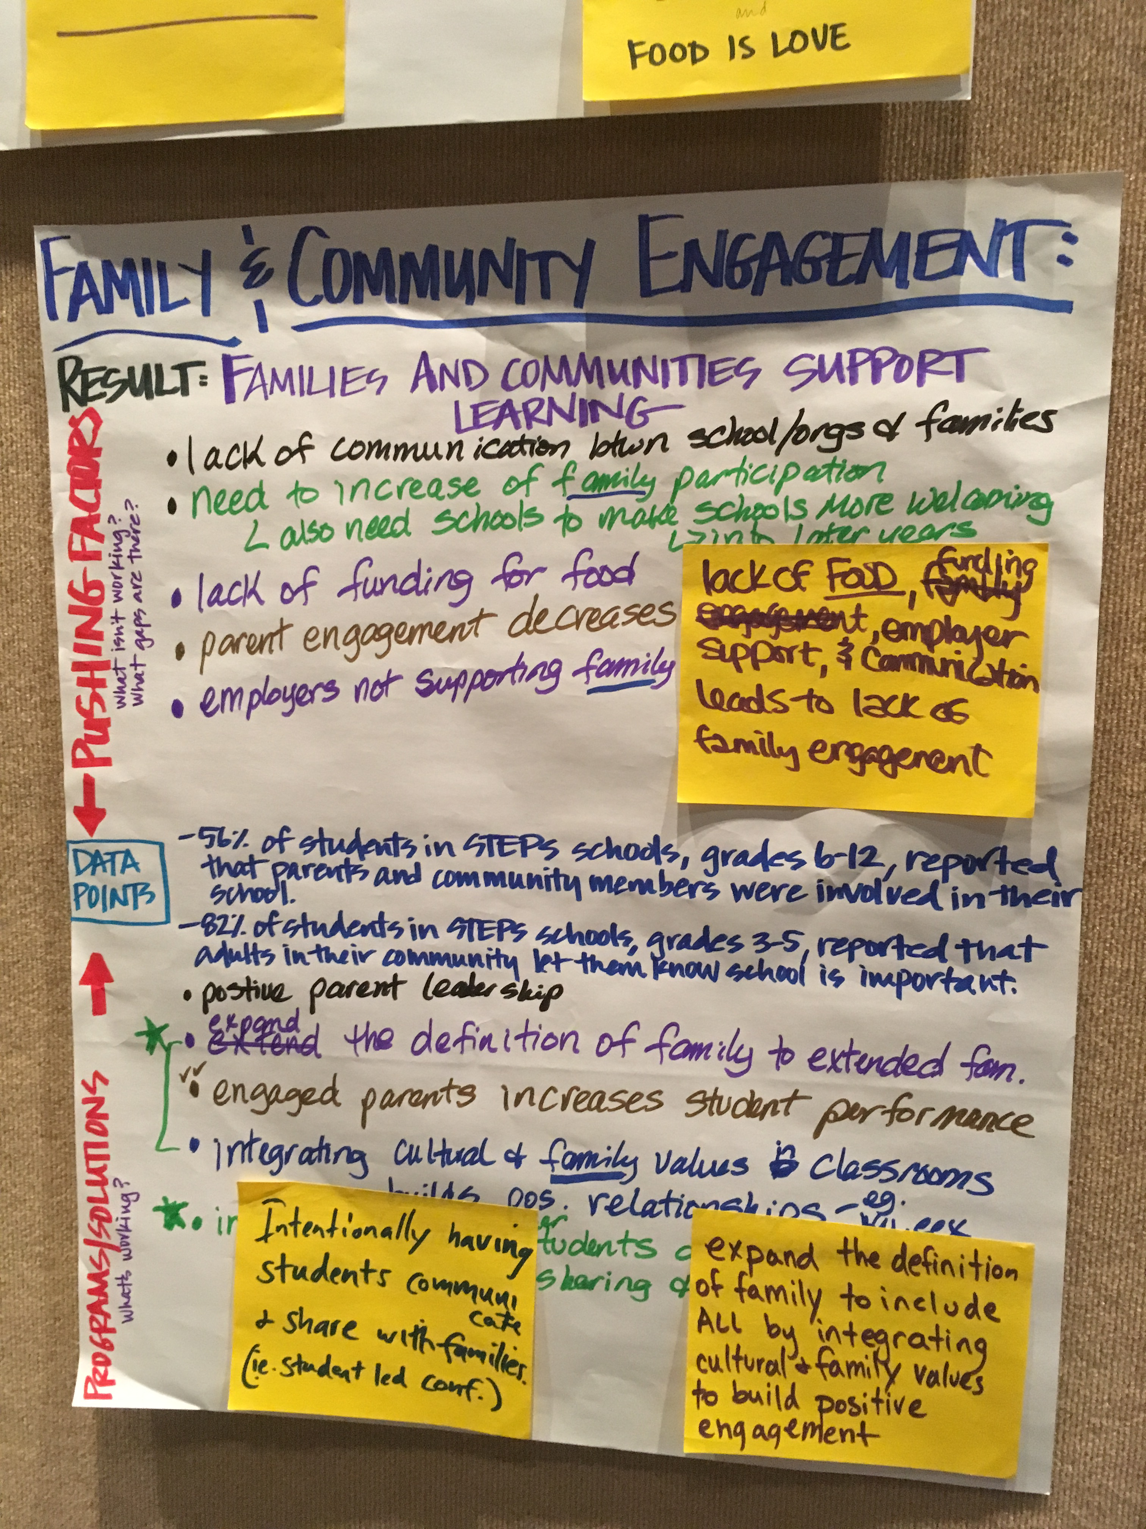
What’s working? - PROGRAMS/SOLUTIONS:
- Positive parent leadership
- Expand the definition of family to extended family => related 0- integrating cultural & family values in classrooms builds positive relations; e.g. Ku.eex (potlatch)*
- Engaged parents increases student performance
- Intentionally make older students a part of the communication sharing & activities; e.g. Student led conferences
- Community centers exist as resources of family and student engagement
- Schools can often be a place of community = HUB; related, events builds relationship w/families.
- Food is LOVE
- Building relationships is a resiliency building factor
- Building positive connections between schools/orgs and families*
- Clear & consistent communication helps develop relationships, e.g. Class dojo app

SCHOOL CLIMATE

RESULT: Students feel safe in their schools & community

Data Points:
- At STEPS schools, students grade 3-5: 70% said they felt safe at school and 36% said other students treat them with respect.
- At STEPS schools, students grade 6-12: 60% said they felt safe at school and 26% said other students treat them with respect.

What isn’t working? What gaps are there?
- Student voices not being heard
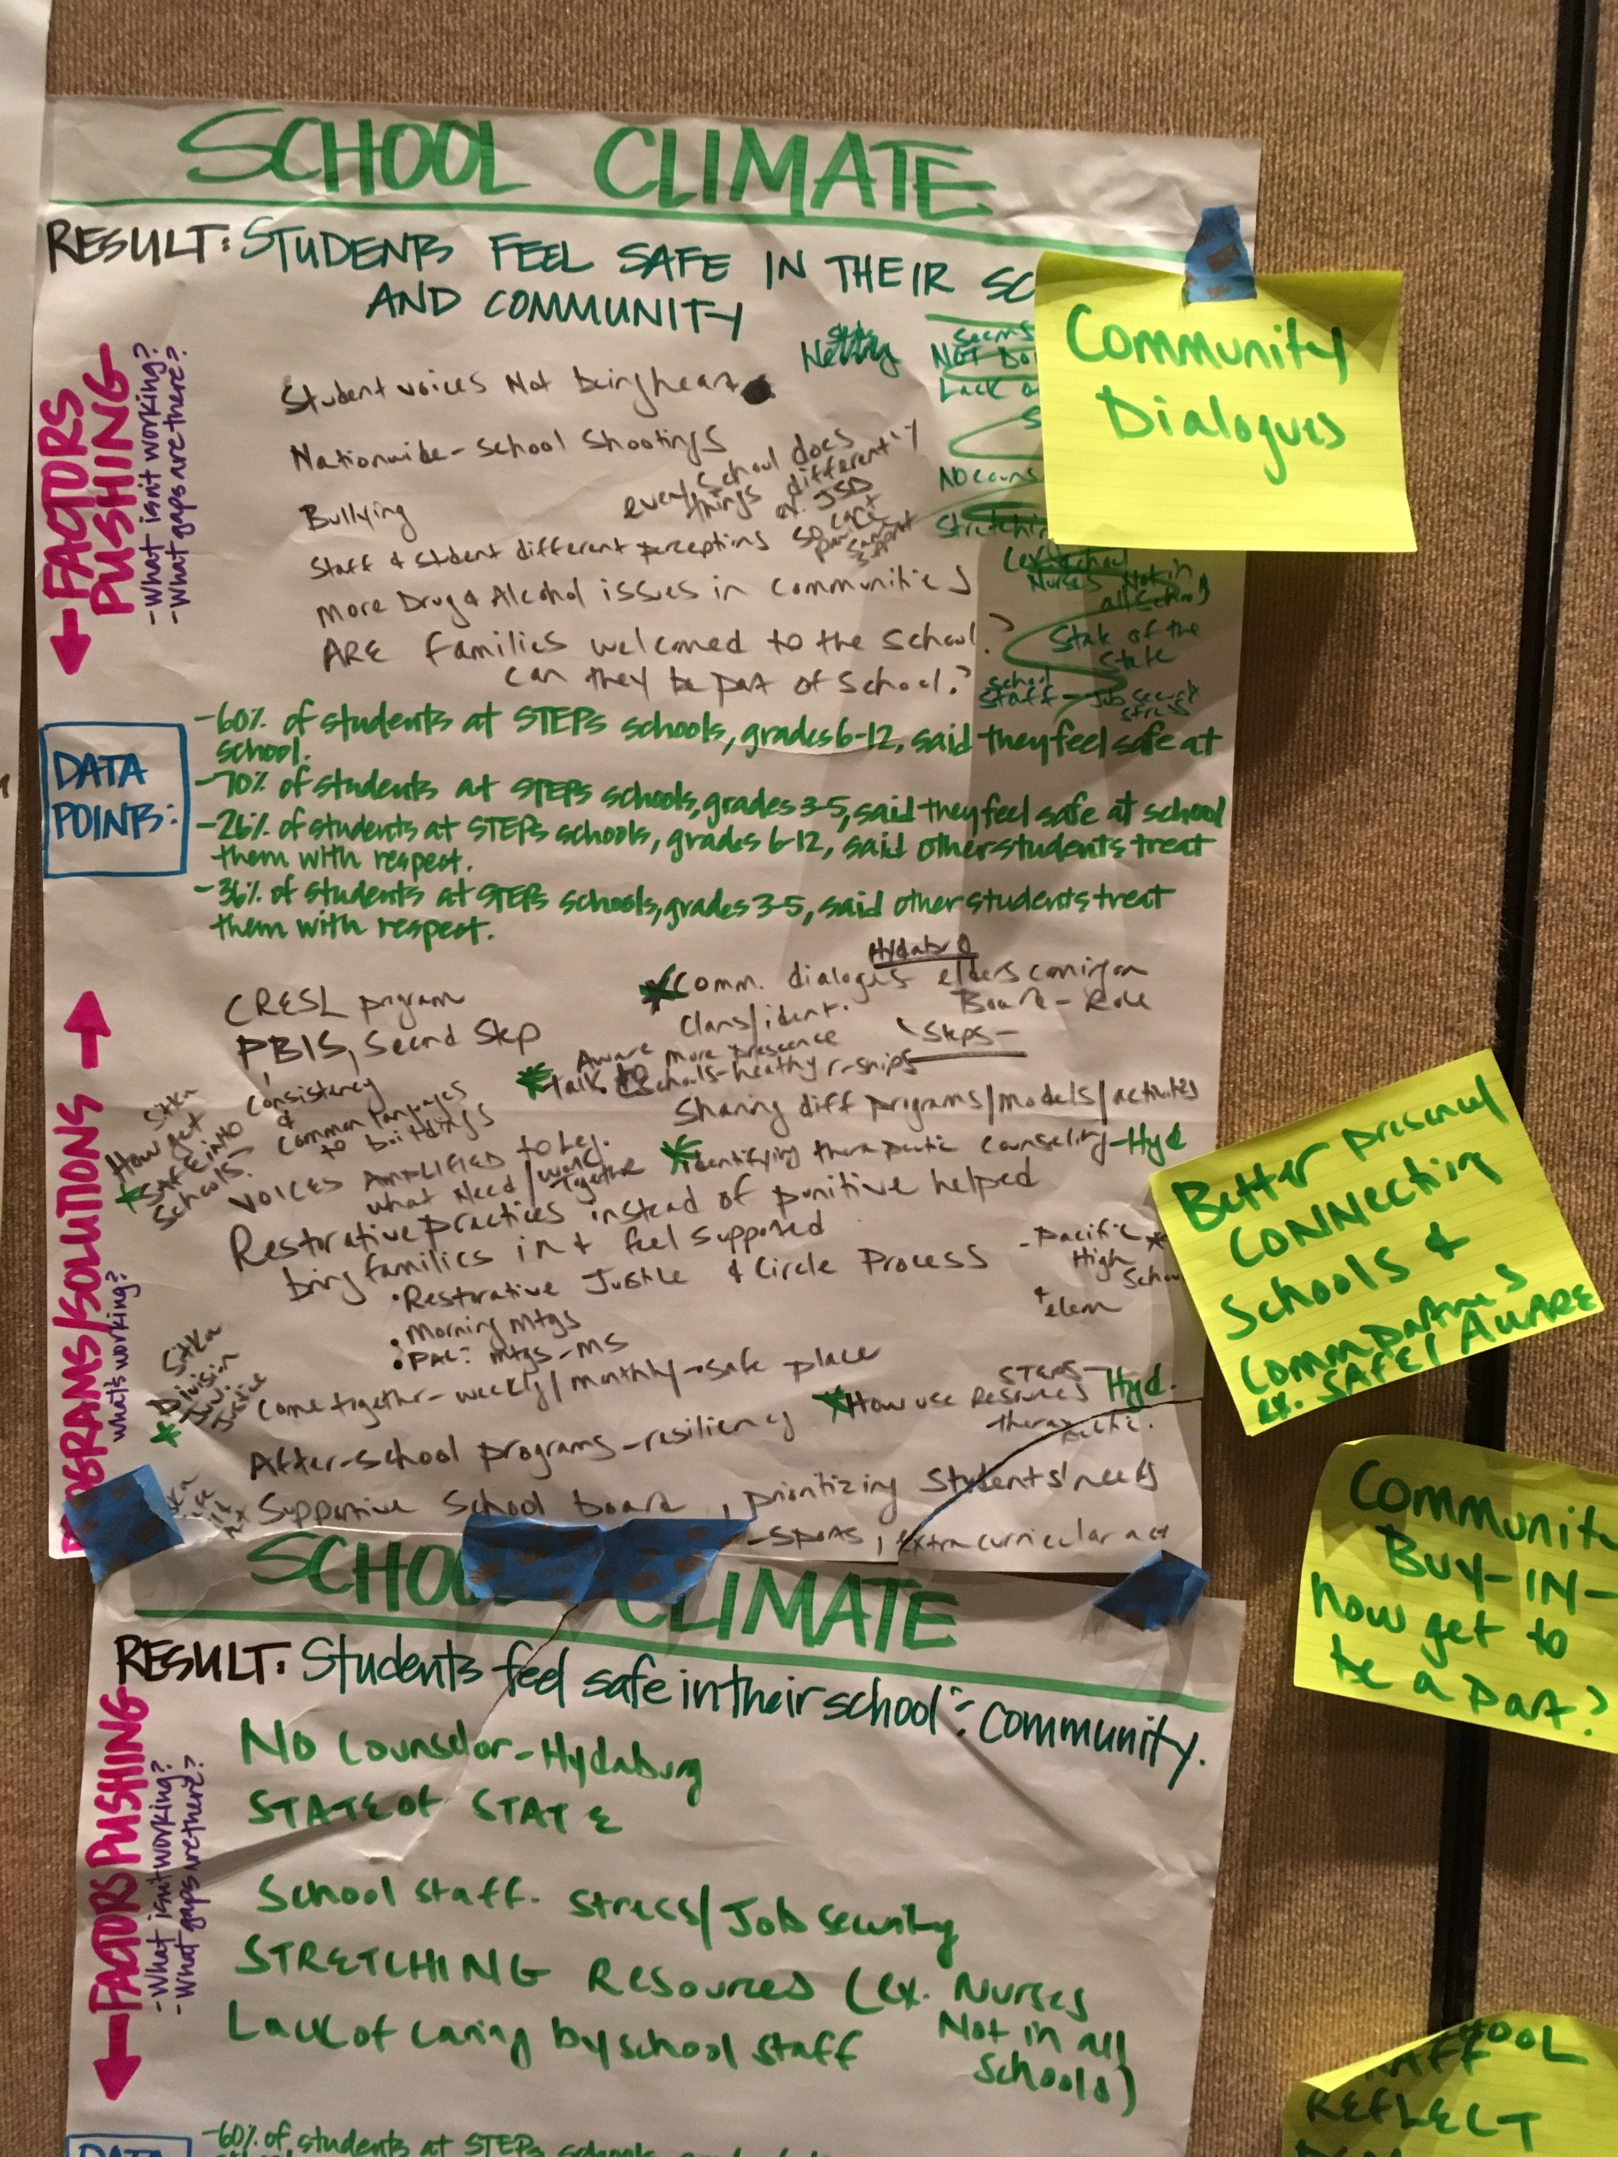
- Nationwide – school shootings
- Bullying
- Staff & student different perceptions
- Every school does tings differently ex. JSD can’t provide same support
- More drugs & alcohol issues in communities
- No counselor – Hydaburg
- State of State
- School staff – stress/job security
- Stretching Resources, ex. Nurses not in all schools
- Lack of caring by school staff

What’s working? - PROGRAMS/SOLUTIONS:
- CRESL program
- Community dialogs – elders carrying role on clans/identity
- Aware – more presence, talk to schools – healthy relationships; sharing different programs/models/activities*
- Identifying therapeutic counseling (Hydaburg)*
- Restorative practices instead of punitive helped bring families in & feel supported
- Restorative Justice & Circle Process
- Training and emotional first aid, counselors, other staff
- Youth voices, ex. Youth panel
- Safety policy workshops
- Older students help
- Trauma sensitive schools and conversations – Juneau
- Make more feel good
- After school hours
- Speak with them not to them

SUBSTANCE ABUSE PREVENTION

RESULT: Students are not abusing drugs and alcohol

Data points:
- 66% of students in STEPS schools, grades 6-12, have not observed other students engaging in drug or alcohol use at school or school events in the past year
- 61% of students in SE AK & 53% of Alaska Native students reported that they have not abused substances

What isn’t working? What gaps are there?
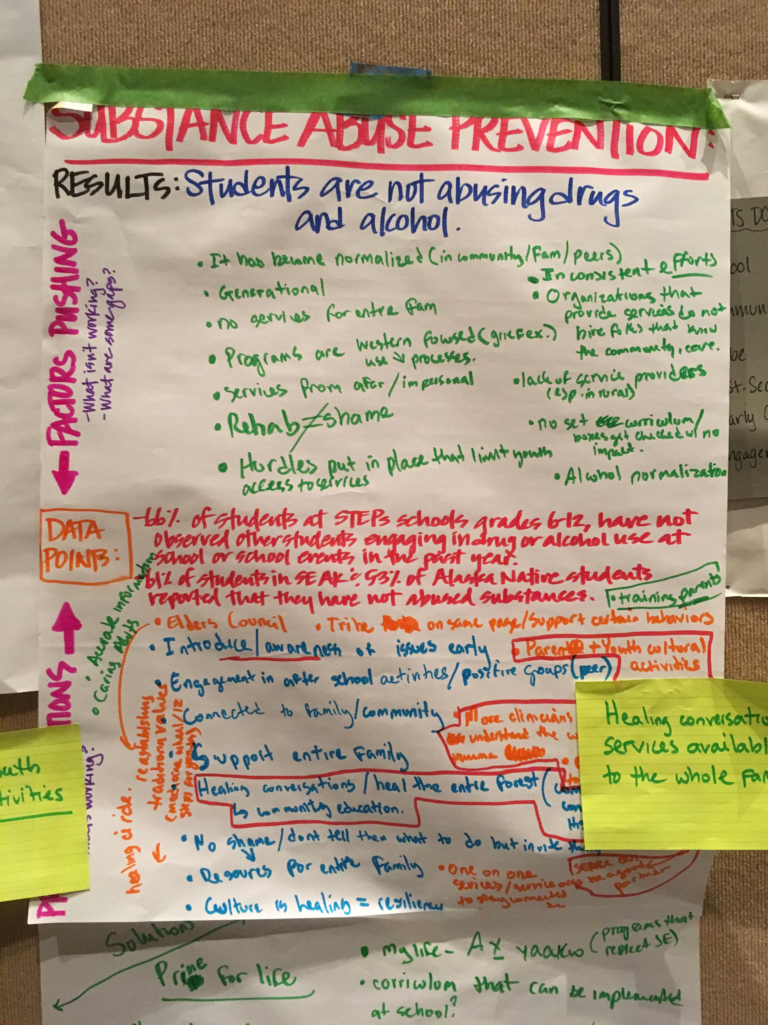
- It has become normalized in community/family/peers
- Generational
- No services for entire family
- Programs are western focused, ex. Grief – use processes
- Hurdles put in place that limit your access to services
- Inconsistent efforts
- Organizations that provide services hire folks that do not know community or don’t care
- Lack of service providers
- No set curriculum, boxes get checked with no impact

What’s working? - PROGRAMS/SOLUTIONS:
- Introduce, awareness of issues early
- Parent + Youth cultural activities*
- More clinicians that understand the culture, trauma*
- Healing conversations – heal the entire forest by community education*
- No shame, don’t tell them what to do but invite them
- Resources for entire family
- Culture is healing = resiliency
- One on one services to stay connected to community
- Training parents*

Note:
Bulleted items marked with an asterisk (*) denotes key, important as decided by group

EARLY YEARS

RESULT: Kindergartners are ready to succeed

Data points:
- Less than 28% of kids in STEPS communities enter K with age appropriate functioning (11 out of 13 goals meet on Alaska Developmental Profile/thread)

What isn’t working? What gaps are there?
- Access/affordability/quality early care and learning
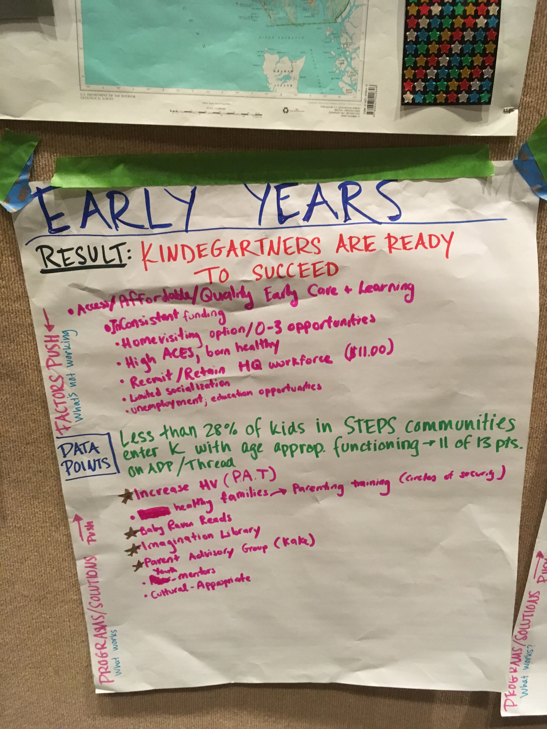
- Inconsistent funding
- Home visiting option
- O-3 opportunities
- High ACES, born healthy
- Recruit/retain high quality workforce ($11.00)
- Limited socialization
- Unemployment, education opportunities

What’s working? - PROGRAMS/SOLUTIONS:
- Increase home visiting (PAT)
- Healthy families -> Parent training (Circles of Security)
- Baby Raven Reads
- Imagination Library
- Youth mentors
- Culturally appropriate

SCHOOL SUCCESS

RESULTS: Students are proficient in core subjects

Data Points: 26% of STEPS students are proficient in math, 33% of STEPS students are proficient in English, 15% of AK Native students are proficient in math, 21% of AK Native students are proficient in English (PEAKS 2018)

What isn’t working? What gaps are there?
- Hard to make partnership fir with schools
- How to get parents who aren’t engaged engaged?
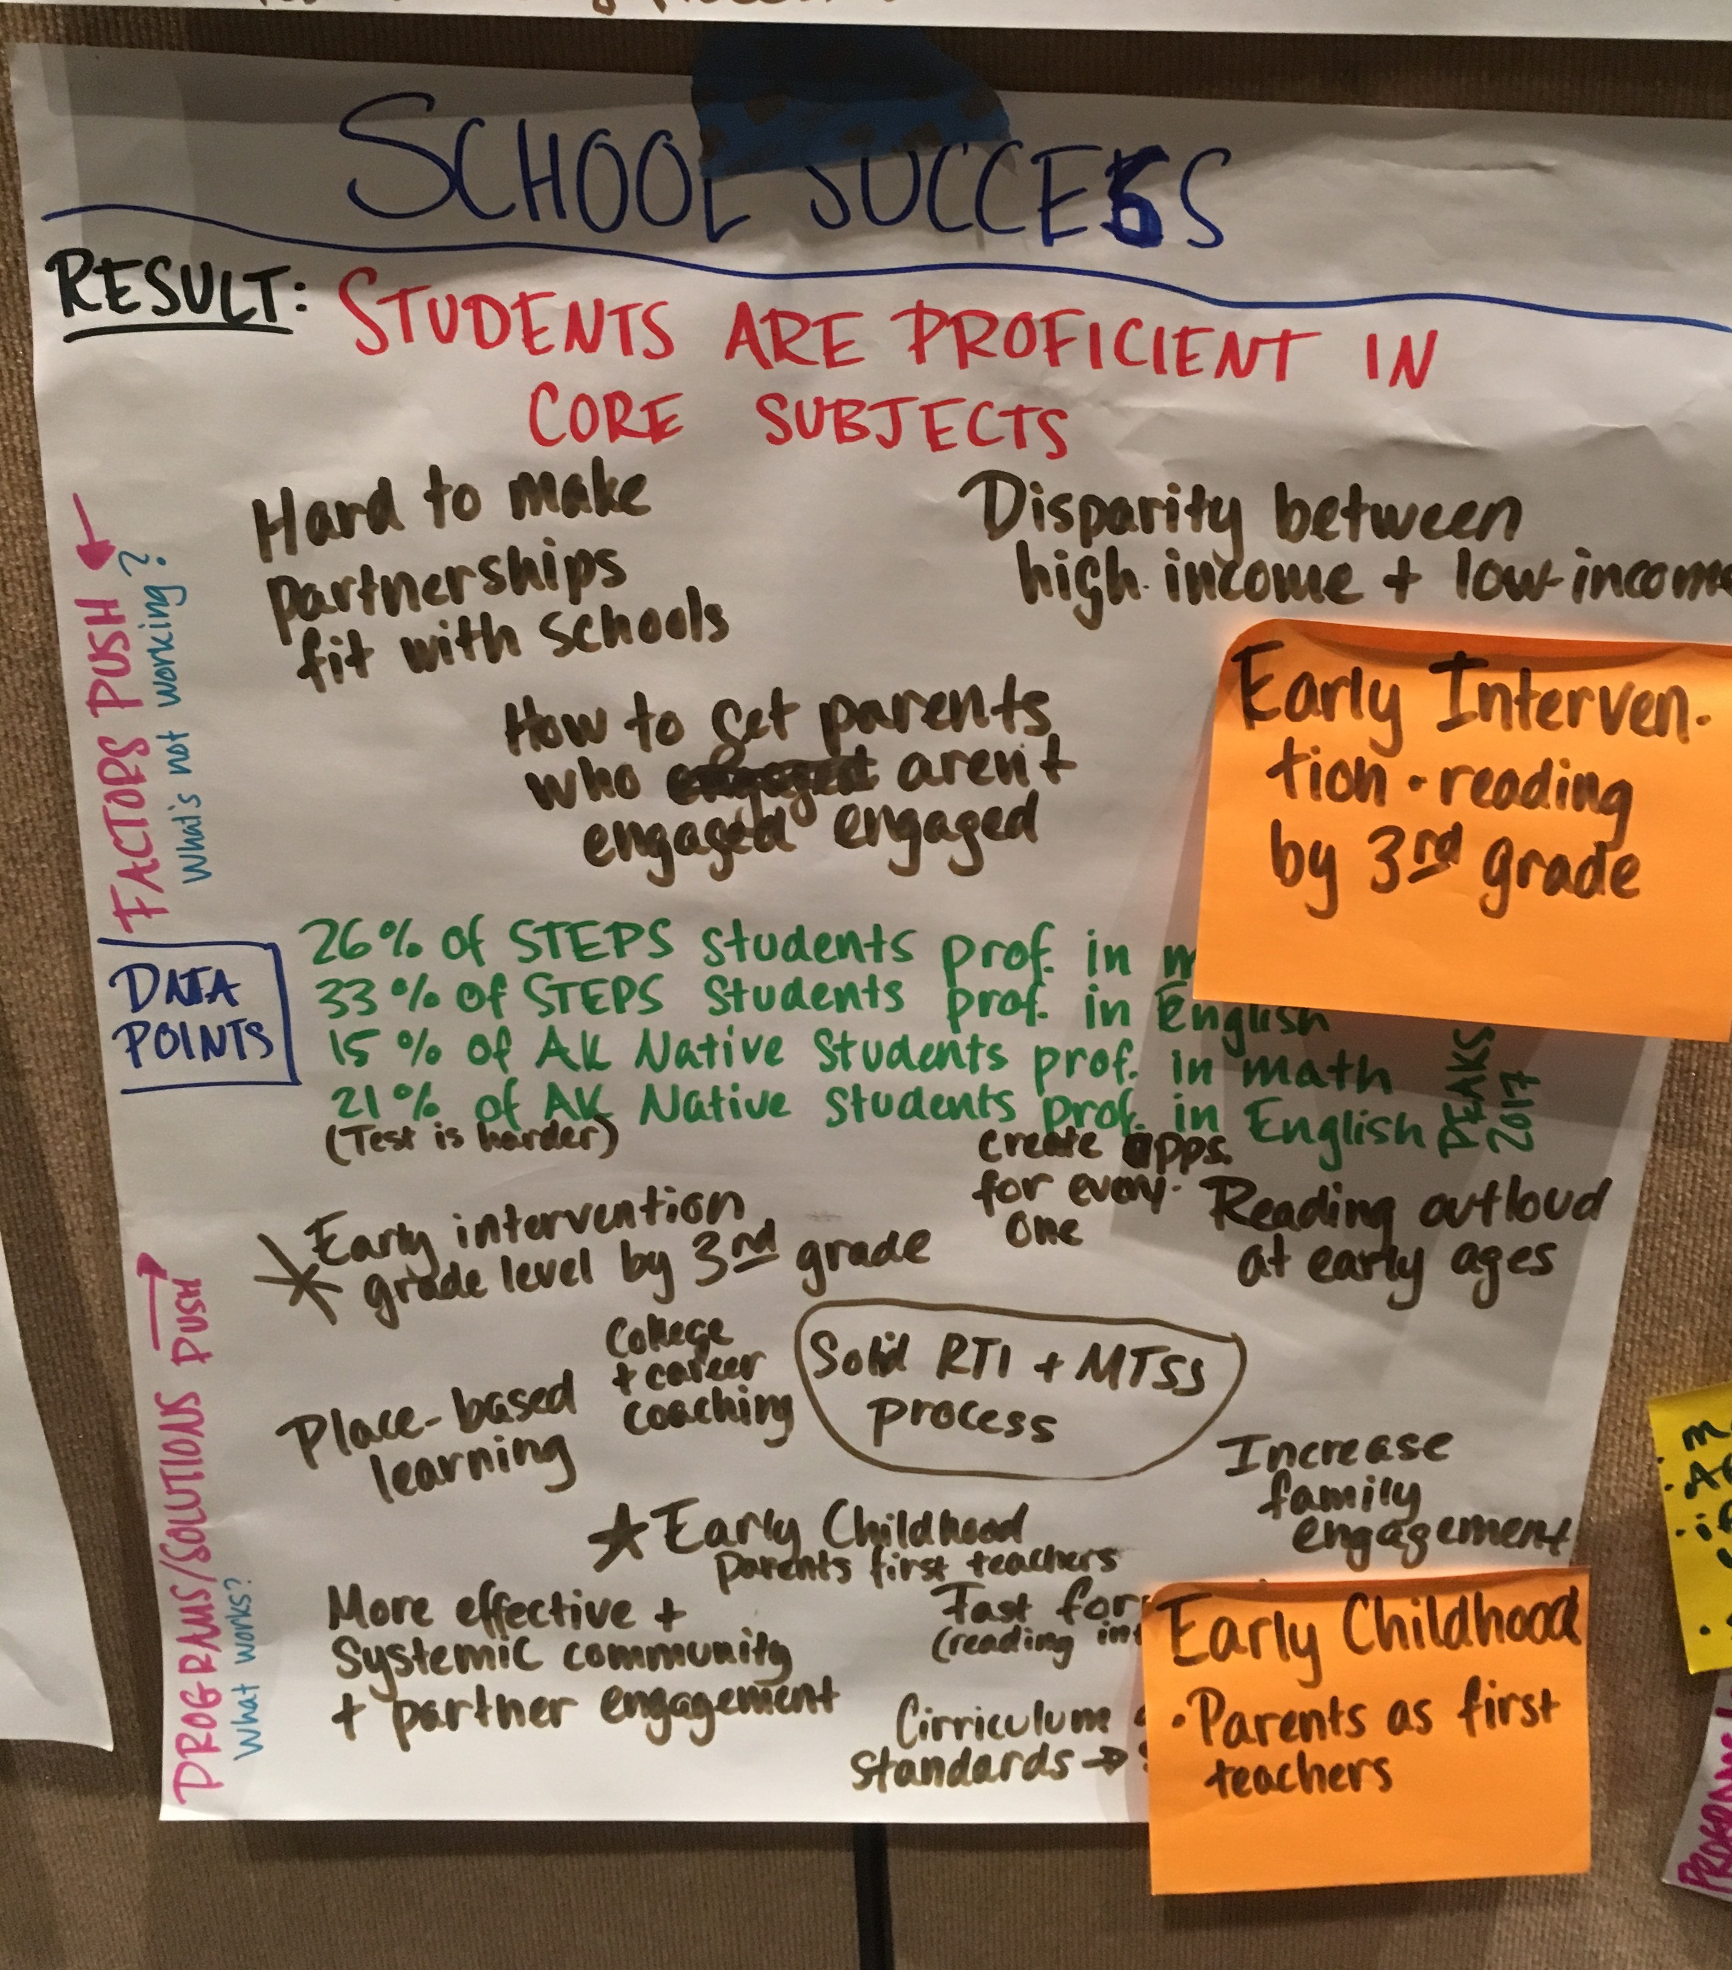
- Disparity between high income and low income
- Lack of relevant information being taught -> Teachers experts in subject matter, not in applicability
- Lack of curriculum relevant to Alaska Schools
- Funds for education being misused (Money for special ed verse money for school preparation)
- High turnover rates within teachers & staff
- Teachers NOT trauma informed
- Need housing for families to stay long-term
- On-sight counselors

What’s working? - PROGRAMS/SOLUTIONS:
- Early intervention grade level by 3rd grade
- Place-based learning
- College & career coaching
- Early childhood – parents first teacher
- More effective and systemic community & partner engagement
- Increase family engagement
- Fast forward (reading intervention)
- Curriculum standards
- Programs (ACCR) giving students experience of post-secondary education (working)
- Need of community members to be informed about post-secondary processes
- Need community to help with resources for classroom teachers.

POST-SECONDARY TRANSITIONS

RESULTS: High School graduates obtain post-secondary degree or credential

Data Points: Fewer than 50% of SE Students enroll (Commission on Post-Secondary)
37% of white SE Alaskans have BA (Network/McDowell)
17% of non-white SE Alaskans have BA
75% of STEPS students said they very much wanted to pursue more education after HS (SCCS 2018)

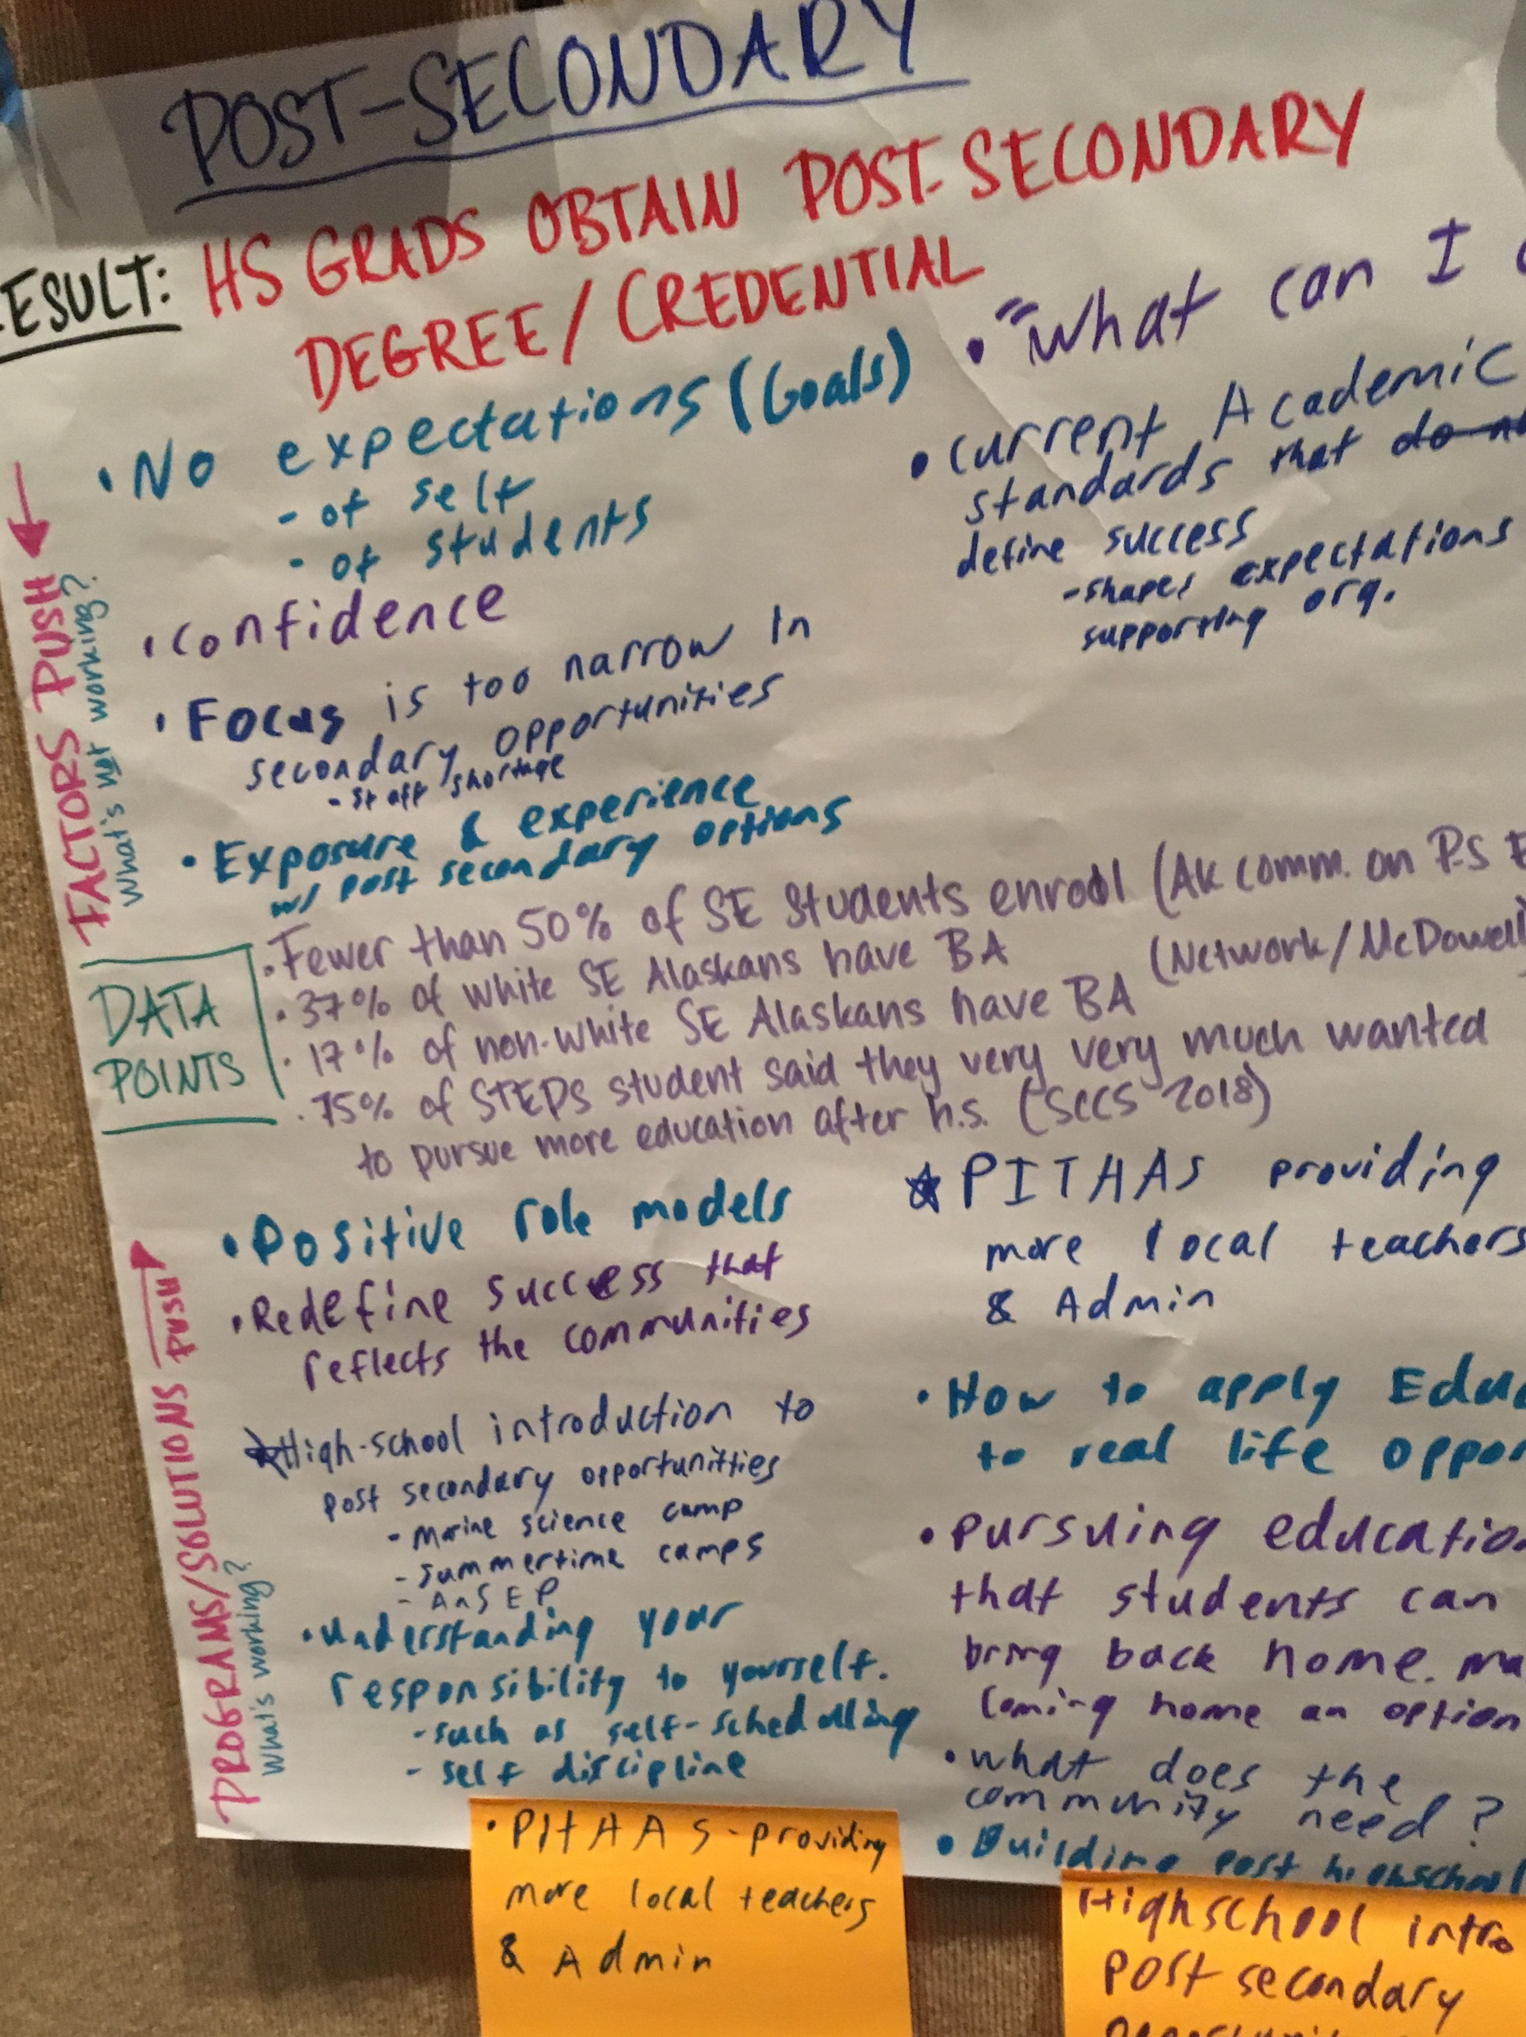
What isn’t working? What gaps are there?
- No expectation (goals) of self, of students
- Confidence
- Focus is too narrow in secondary opportunities
- Not enough exposure and experience to options
- Current academic standards that define success
- Financial restrictions
- Knowing the options & navigation
- Supports for navigating the options & applications
- Fear of the unknown
- Navigating college or new environments
- Finding student’s strength – how to utilize it
- What can I do in my community?

What’s working? - PROGRAMS/SOLUTIONS:
- Positive role models
- Redefine success that reflects the communities
- High School introduction to post-secondary opportunities: marines science camp, summer camps, ANSEP
- Understanding your responsibility to yourself, such as self-scheduling and self-discipline.
- PITTAS providing more local teachers & admin
- How to apply education to real life opportunities
- Pursuing education that students can bring back home – make coming home an option
- What does the community need?
- Building past high school

CULTURAL INTEGRATION

RESULTS: Schools are culturally responsive.

Data Points: 44% of students in STEPS schools, grades 6 – 12 reported, feeling culturally connected at school.

What isn’t working? What gaps are there?
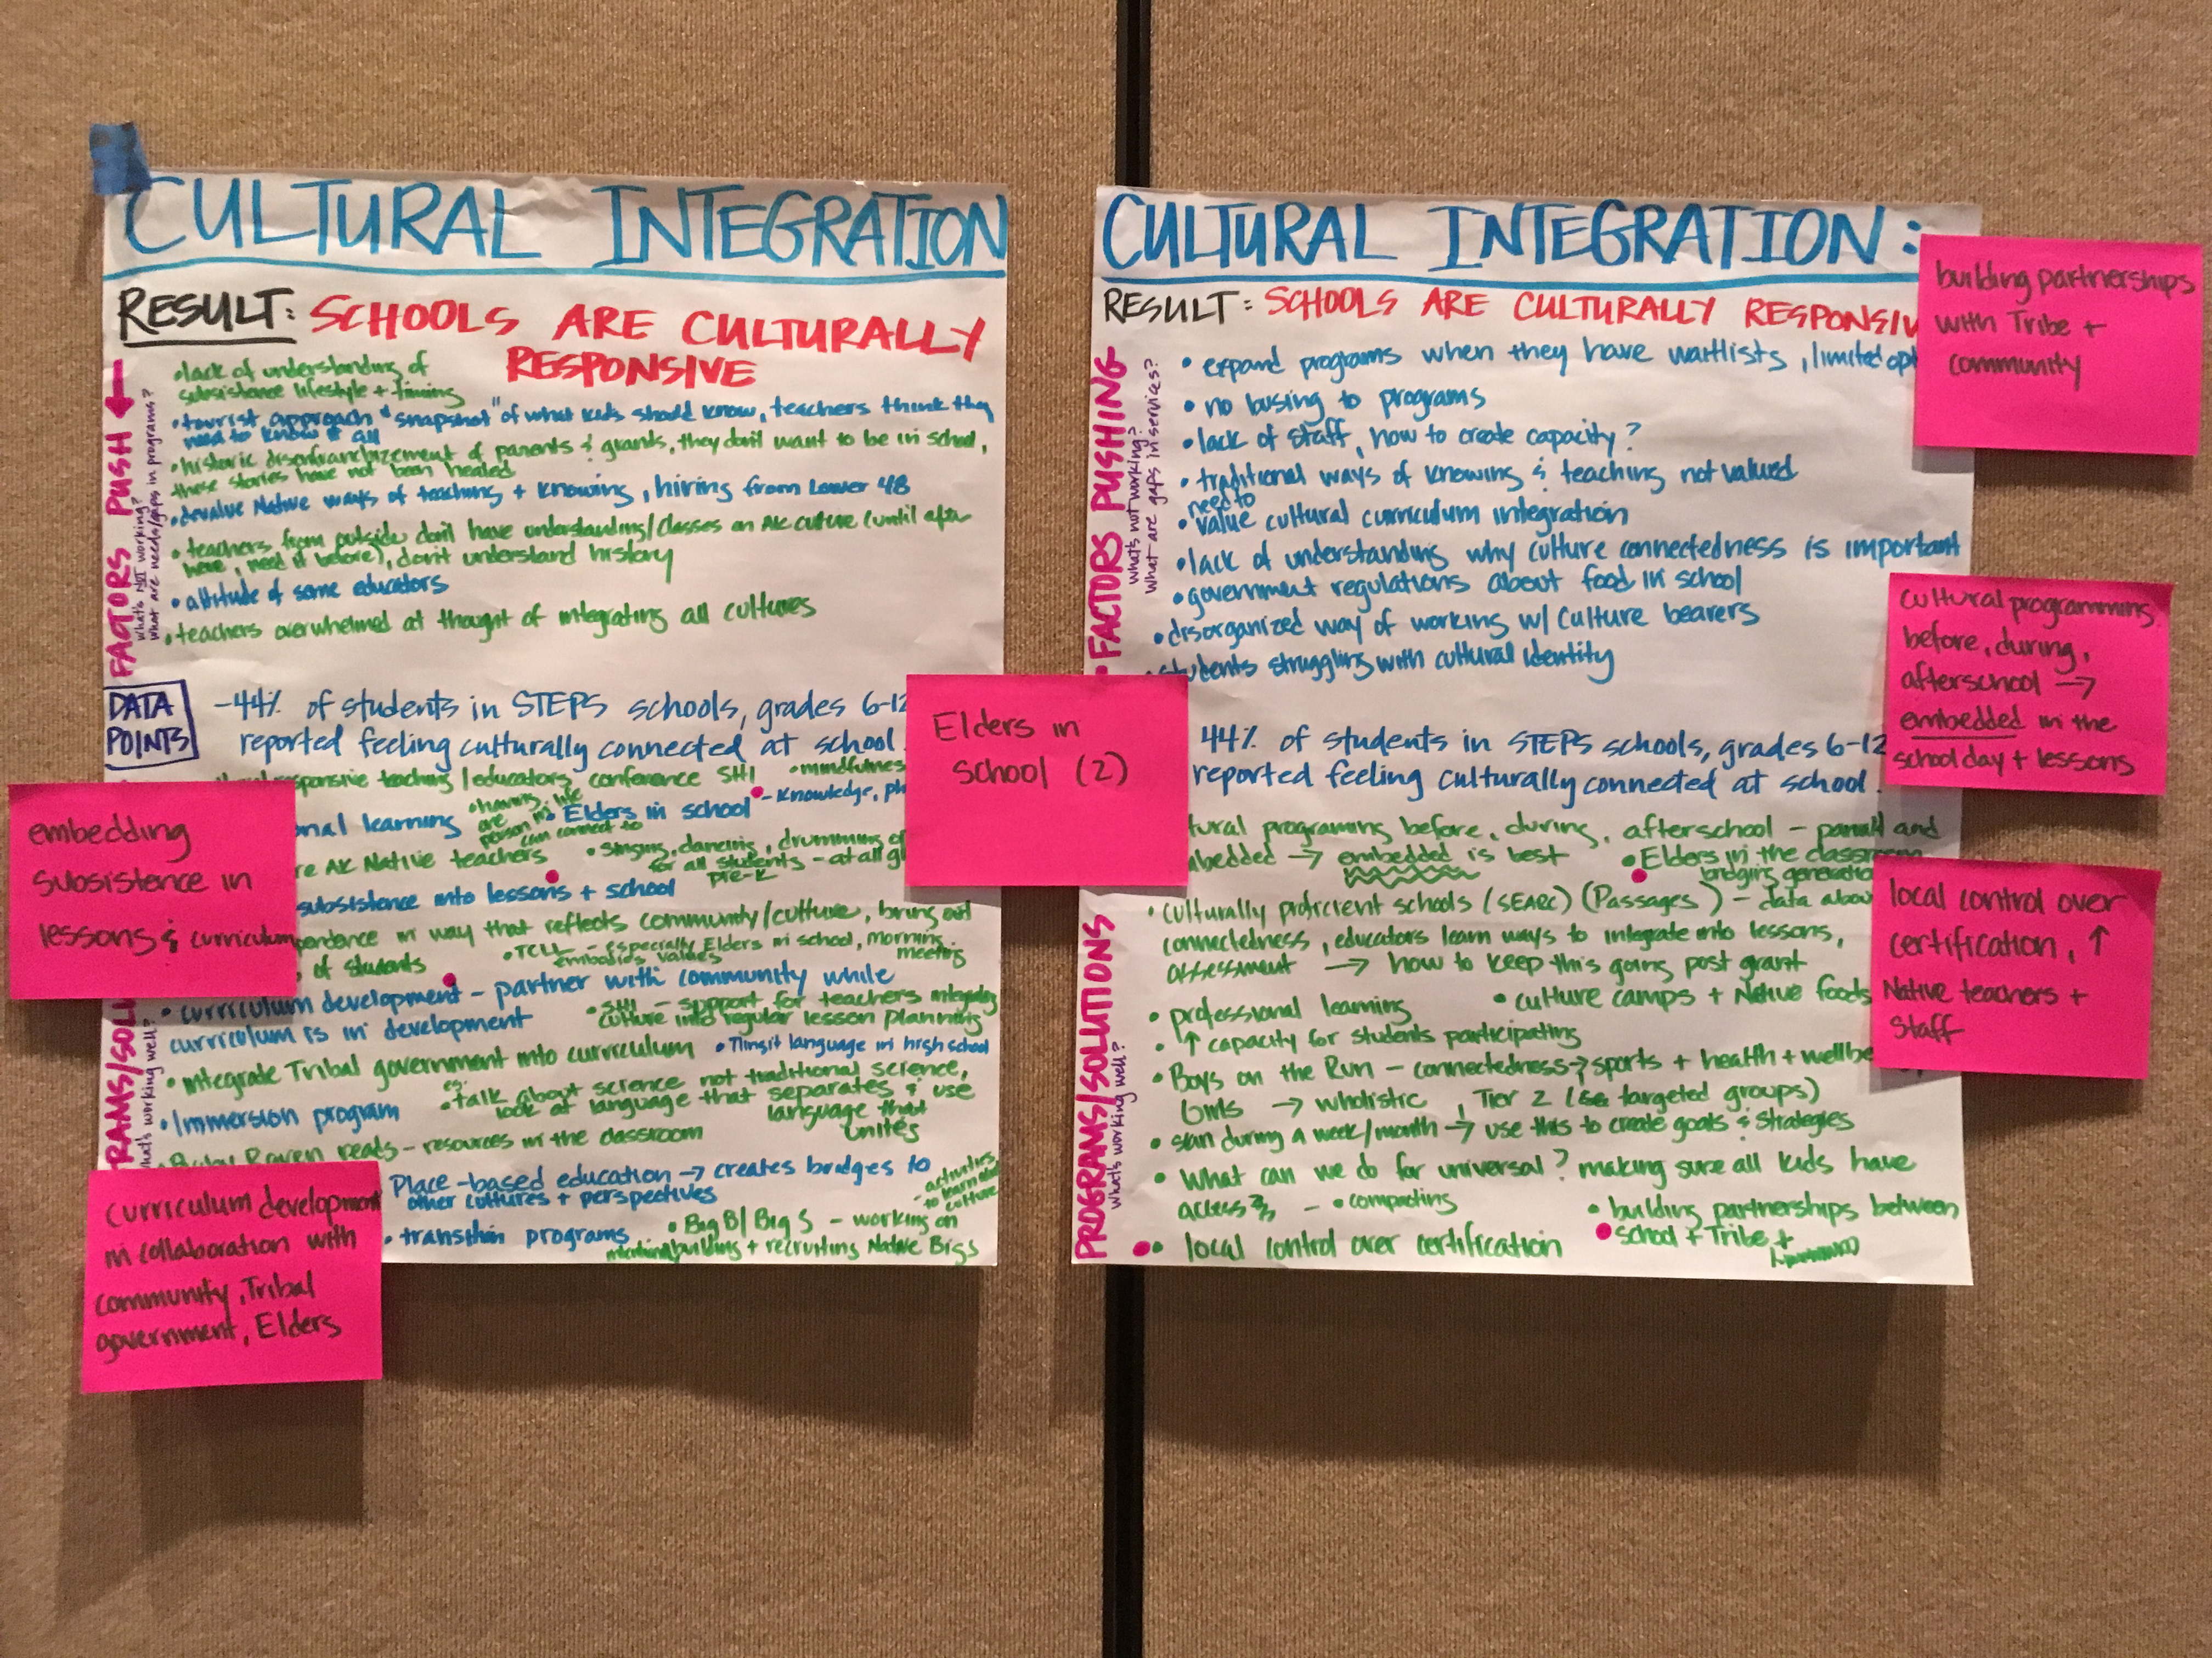
- Limited options – don’t expand programs when they have waitlists
- No busing to programs
- Lack of staff, how to create capacity?
- Traditional ways of knowing and teaching not valued
- Need to value cultural curriculum integration
- Lack of understanding why cultural connectedness is important
- Government regulations about food in school
- Disorganized way of working with culture bearers
- Students struggling with cultural identity

What’s working? - PROGRAMS/SOLUTIONS:

- Cultural programing before, during, afterschool -> embedded in the school day and lessons is best
- Culturally proficient schools (SERRC) (Passages) – data about connectedness, educators learn ways t integrate into lessons, assessment -> how to keep this going past grant
- Culture camps and native foods
- Professional learning
- Increase capacity for students participating
- Boys Run/Girls on the run – connectedness -> sports & health & wellbeing, holistic, Tier 2 (for targeted groups)- give all kids access
- Scan during a week/month -> Use these to create goals & strategies
- Local control over certification
- Building partnership between school & tribe & community
- Elders in the classroom bridging generations
- Career connections
- Outside High School community experiences – career connections, Alaska close-up – legislative experience, Adult ed center, upward bound, college horizons, RAHI, Mt. Edgecomb post-HS embedded in curriculum
- Adult education center
- Provide a mentor
- Resource Bank (spreadsheet)
- Broadening post-secondary opportunities option focus with in high school
- Provide succession planning

