STEPS Data Work Group
Foundational Document

Supporting Transitions and Educational Promise Southeast Alaska is a Collective Impact effort involving five school districts, tribes, state agencies, the university, and non-profit organizations in Juneau, Sitka, Hoonah, Angoon, Hydaburg, and Klukwan. The goal is to work with schools, families, and the community to improve educational outcomes for all kids in Southeast.

There are five key components to the Collective Impact model:

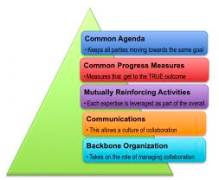

The goal of the Data Work Group is to oversee the development of common progress measures that:
- Are internally meaningful for guiding our group toward our shared vision (common agenda)
- Can be communicated to the public in a format and narrative that inspires action and investment
- And/or, in some cases, are simply necessary for the purposes of reporting on the STEPS Alaska Promise Neighborhood grant.

Types of data
The STEPS project will be looking at population level indicators to guide our work. Much of this information is publically available and will be put into the Clear Impact Scorecard for the purposes of reporting as well as tracking longitudinally.

Program level performance measures will also be used to help evaluate and tell the story of success around specific solutions or activities (i.e. the number of kids enrolled in an afterschool program or the number of care providers who would recommend a training).

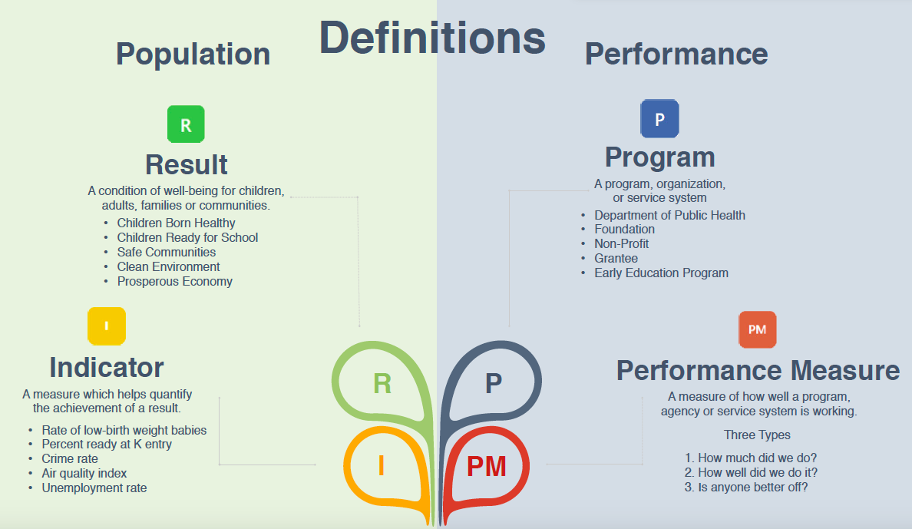

The Seattle area Road Map Project also differentiates between population level data about individuals (i.e. student performance scores) and systems data (i.e. the number of licensed childcare providers in low-income communities) in order to focus measurement on how well the collective impact initiative is doing at making systems change.

It should also be noted that while we may need to track many indicators and performance measures to guide our collective impact effort, we should only focus on the five (max) most salient measures when communicating with the public. To be successful, the data must be paired with stories and must reflect what matters to the community (not what the data-heads think is important.)

What we need to measure
Federally Required GPRAs:

1) Kinder-readiness
2) Math and English proficiency,
grades 3-8
3) Attendance, grades 6-9
4) Graduation rates
5) Post-Secondary enrollment and
completion
6) Fruit & veggie consumption
7) Student safety
8) Stable communities
9) Families read/talk about
college/career
10) Broadband/computing access
Along with the grant from the US Dept of ED comes the mandate to track federally required GPRAs (Government Performance and Accounting Act.)

This is written about extensively in the Performance Guidance manual put together by our technical assistance providers, the Urban Institute, and more specifically in an updated version of Chapter 4 (as an FY17 grantee, STEPS only needs to track ten GPRAs rather than fifteen.)
Additional Indicators Proposed in STEPS Grant Application

- Childcare availability
- Substance use
- Culturally responsive schools
- Domestic violence and suicide
- Adults who support schools

What we plan to measure
In the grant we proposed measuring several other measures that will help indicate our success towards creating culturally responsive, trauma informed schools.

What we are considering measuring
Baking Bread:

There is tons of flour (data) sitting in the state silos and lots of hungry people (looking for data to tell important stories and inspire change), but no one to bake the bread (make sense of the data in a meaningful way by focusing on the right info, and putting it into narrative and format that is digestible for the public to digest.)

– A paraphrased version of Pat Sidmore’s analogy.
On July 31, 2018 Pat Sidmore (SOA – Mental Health Trust Board), Kevin Ritchie (Juneau volunteer), Phil Loseby (Juneau SD Data manager), Bridget Weiss (Juneau SD Student Services), Ted Wilson (Juneau SD Director of Learning), Ben Glover (Hydaburg Principal), Will Kronich (Tlingit & Haida), Supanika Ackerman (DEED), Mandy Evans (Sitka SD), Claudia Plesa and Emily Ferry (AASB) thought about our data goals by answering the following questions:
- In Southeast Alaska we could show that an opportunity gap exists - and focus resources on closing it - by tracking ____ indicators.
- We would know that we are making a difference for kids in Southeast Alaska if we were able to move the dial on ____ indicators.
- A really important story that is not being told is ____.

From that conversation we may want to consider measuring:

Indicators
- Student facility with language
- Community health
- Students who are homeless and/or connected with OCS
- PRAMS data connected with OCS data
- Disproportionality (over-representation) by discipline and special ed
- Local/state investment in early childhood
- Link ACES data with child outcome data
- Difference between gender and income
- Post HS training and employment (Kodiak and Barrow have done, State collects more details for special ed students, contact: David Tarsey)

Performance Measures
- Family engagement (# participating in different demographics, # on board, # of activities planned, # completed)
- # of community conversations and trauma trainings
- # of childcare providers enrolled in Learn & Grow

Untold Stories:
- O-5 years is critical to positive adult development
- Less drinking by high school students
- Impact of generational trauma in public schools
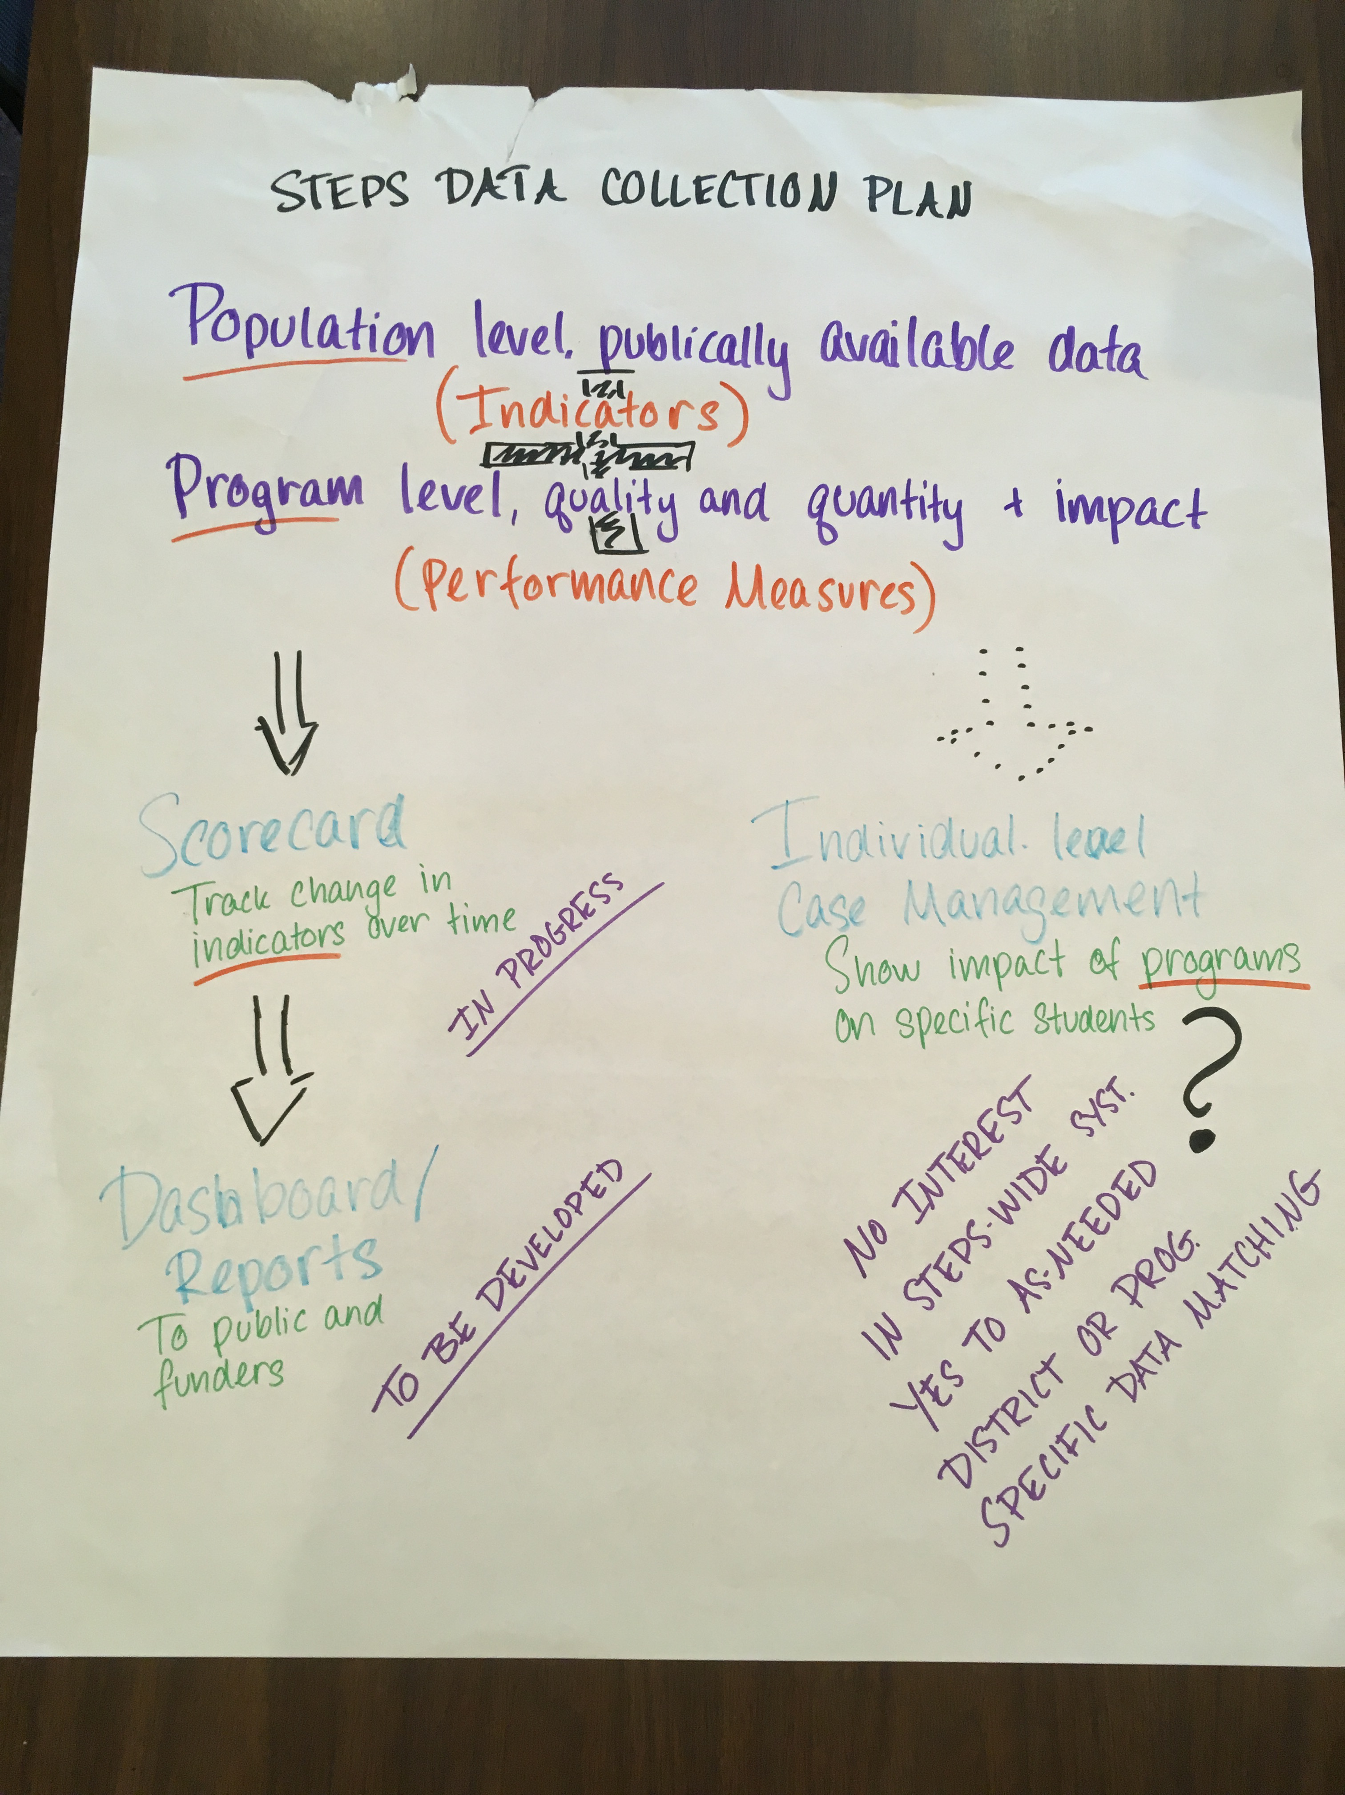
- How will we help kids succeed? Why is data gathering/reporting important?

Additional Notes and Resources:
- We should be clear about what we need to measure for the grant, for our internal guidance, and what is helpful for public consumption and use.
- It is essential that we’re focused on what communities care about
- Think (and talk) about systems – not student deficits.
- Framework Institute’s How to tell a Story and Hart and Risely’s Meaningful Differences are helpful.

Questions to Ponder:
- Given that our goal is to create a system where ALL students can succeed, it will be important to show where inequities exist (without getting into deficit thinking.) We proposed in the grant application to compare whole population data with that of Alaska Native students. Do we want to include mixed race or other minority races in that same category? Are there other demographic breakdowns we should consider such as gender, income, etc.?

- We have used summative (ADP and PEAKS) data to provide a baseline for kindergarten readiness and core academic success. The PEAKS data is particularly coarse with only four categories – hard to move the needle. Would it be better to use formative assessments like Teaching Strategies Gold (pre-K through 3rd grade) and MAPS?

- In addition to tracking specific indicators, STEPS needs to set targets for improving those indicators over the five years of the project (by December 2022.) The Indicators and Sources table submitted with the grant contains some proposed targets, but those should be evaluated and adjusted by this and other relevant work groups.

- There is a wealth of national data readily available that shows, for example, the importance of investing in early childhood education, adopting a trauma-informed approach, and teaching in ways that are culturally relevant. How can we best utilize and communicate (translate) that existing data to make it relevant to Southeast?

- At the meeting in July 2018 the Data Work Group discussed the merits of pairing individual level data in a case management system in order to track and evaluate the impact of programs. For some school districts this approach would be quite valuable. Other school districts felt that there was already too much focus on individual-level data; further focus on that could take away from efforts to prioritize systems. It was determined that if school districts wanted to pursue matching individual level data they could do that within their existing systems.

