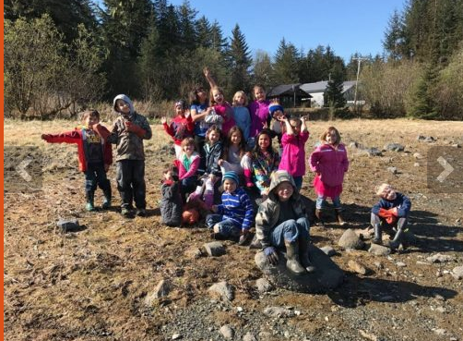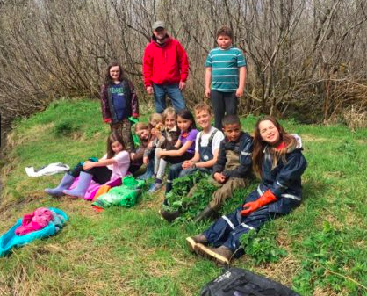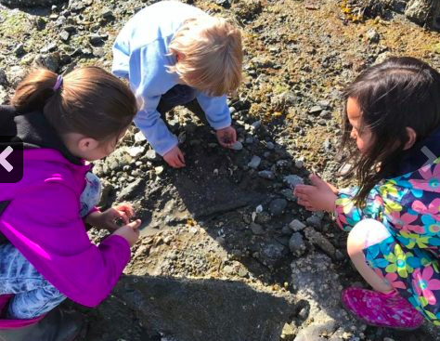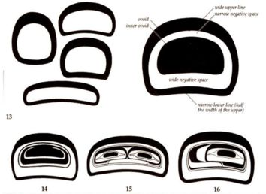

Yakutat

School District

K-12 & Post-Secondary:

* STEM/STEAM/Place-Based Learning
* Professional Development
* Trauma Informed Practices
* Culturally Responsive Integration
* Post-Secondary Mentoring

Engage & Prevent:

* Family & Community Engagement
* Nutrition

STEPS is a data-driven collective impact focusing on cradle to career solutions and strategies

in Angoon, Hoonah, Hydaburg, Juneau, Yakutat, Klukwan, and Sitka.

For additional information contact the

Association of Alaska School Boards

STEPSAK@aasb.org, 907-463-1660

#### Organization Contact – William Sprott Williams@yakutatschools.org, 907 784-3317

* SE Early Coordination
* SE K-12 Schools & Post-Secondary
* SE Family Alliance
* Creating Conditions
* Intervention-Prevention
* Steering & Collaborative Impact
* Data Coordination

* Co-Chair or Chair

Supporting Transitions And Educational Promise Southeast Alaska (STEPS) Promise Neighborhoods Grant

Early Childhood:

* Headstart
* Tlingit language Immersion

K-12 & Post-Secondary:

* Afterschool
* Trauma Informed
* Summer Programs
* Vocational Track & Early College Experiences
* Community Dialogues

## **Committees**

## **Partner**

## **Lead**

**STEPS Results and Indicators**

*Partners are working collaboratively to achieve results as measured by the following indicators.*

**Kindergarteners are Ready to Succeed**

⬆ Children entering kindergarten with age appropriate functioning

⬆ Families that have equitable access to quality early childhood care

**Students are Proficient in Core Academic Subjects**

⬆ Students who are at or above grade level according to state math assessments

⬆ Students who are at or above grade level according to English language arts assessments

⬆ Students who are enrolled in college and career readiness preparation courses

**Students Transition from Middle to High School**

⬆ Attendance rate of students in 6-9th grade as defined by average daily attendance

⬇ Chronic absenteeism rate of students in 6-9th grades

**Students Graduate from High School**

⬆ Four-year adjusted cohort graduation rate

**High School Graduates Obtain Post-Secondary Degree or Credential**

⬆ Alaska Native or mixed race students who are enrolled in a two or four-year college after graduation

⬆ Alaska Native or mixed race students who graduate from a 2-4 year college

⬆ Students who report they would like to pursue post-secondary education

**Students are Healthy**

⬆ Children who consume five or more daily servings of fruits and vegetables

⬆ Children who participate in 60 minutes of physical activity daily

**Students Feel Safe at School and in Their Communities**

⬇ Children who do not go to school because they do not feel safe

**Communities are Stable**

⬇ Students who change schools or communities

**Communities are Drug-Free**

⬇ Students using substances

**Schools are Culturally Responsive**

⬆ Students reporting culturally responsive schools

**Students Have Access to 21st Century Tools**

⬆ Students who have school and home access to broadband internet & devices

⬆ Students who have STEM and STEAM opportunities

**Communities are Low Violence**

⬇ Lifetime domestic violence or sexual assault rates of women

⬇ Students who consider suicide

⬇ Students who attempt suicide

**Families and Community Members Support Learning**

⬆ Family members reading to or encouraging their children to read three or more times a week

⬆ Family members talking about the importance of college and career

⬆ Adults who support local schools

*For more information contact 907 463-1660, STEPSAK@aasb.org*