On November 14, 2018, about two dozen members of the community meet at the Yakutat Senior Center to discuss what kids from Yakutat need to succeed. Prior to the meeting students in grades 4 through 12 shared their ideas and community leaders provided their own top ten lists.

This scan is the first phase of Yakutat’s participation in the Supporting Transitions and Educational Promise Southeast Alaska (STEPS) Initiative, a multi-year grant from the US Department of Education in partnership with the Association of Alaska School Boards, five other school districts, Tlingit and Haida, UAS, and several other nonprofits. While schools are at the center of the STEPS work, partnerships with the families, tribes, early childhood providers, post-secondary opportunities, and other community support systems are essential. The community conversations and scan are the foundation of Yakutat’s community work plan.

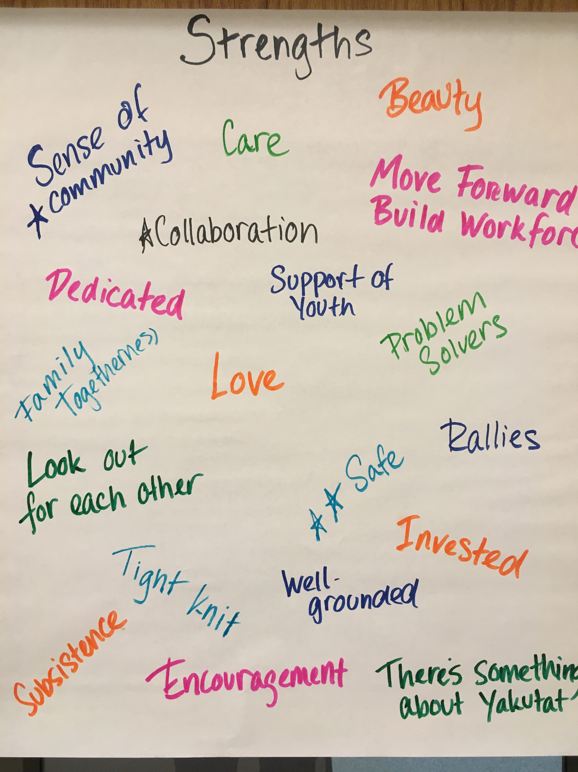
A smaller group was able to develop next steps for several of the strategies on November 15th. Other strategies need to be further developed. In particular, key stakeholders working on cultural integration had limited availability during the time of the meetings.

Strategies that are in bold were mentioned by two or three of the groups (sometimes using different language to convey the same idea). Asterisks mean that more than one person in the group mentioned the idea.

Yakutat will next decide how to put the puzzle pieces together and prioritize strategies. The scan provides insight to help further develop action plans for each strategy and prompt key questions. For example, in order for more classes and dual credit courses to be offered, does internet access need be considered? And would it be possible to craft a position that focused on life skills and included guidance counseling, health education, and helped coordinate job shadowing and other opportunities in the community?

Full notes of the meetings and top 10 lists are also available and provide rich detail about how these goals may be achieved.

How do we strengthen the experience of students K-12?

Community | Students | Top Ten Lists
- Arts, Music, Foreign Language: Need technology/bandwidth, training/professional development  - Hands-on electives (life skills, home ec): need volunteers with skills, time on Fridays  - Guidance Counselor  - Dual Credit: partner with UAS  - Skill certification: need apprenticeships/volunteers  - Community Service: volunteers  - Attendance: Wrap around attendance teams, counselors, interagency, magistrate, extra activities  - Finding gaps of learning – percentage of overall and the impact on students | - More Electives (Home Ec, language classes, music, acting, photography)  - More class options (math, sciences, health, reading, accelerated reading)  - More teachers**  - Library system (keeping track of books)  - Opportunities for Good Eating and Physical Health*  - Lunch/breakfast program*  - Brain snacks  - More open swims  - Sports (football, softball, archery, baseball, rock wall, new gear*)  - Updated books and text-books.  - End school 3:10 – later start;  - Student council*  - Pen pal program, | - Additional Educational Opportunities: ANSEP, 4 Day week with extended courses, Community Service K-12, Agriculture Curriculum, Fabrication Lab, Subsistence & Culture Courses, Culture Courses, Multi-media Classroom, Enrichment (music, theater, art)  - Attendance: staffing for attendance, review board  - Support transitions: pre-k, Elementary, Middle to high school, post-sec;  - School/guidance counselor: college application, financial aide  - Relationships  - Library and Digital books  - Intervention and Support: Math Intervention, Language Arts Intervention;  - Expanded Professional Learning opportunities for staff: MAP seminars, ASTE, Differentiated Instruction, Cultural Relevancy  - Breakfast/lunch/health program*  - Summer & afterschools: STEM

NEXT STEPS – Strengthening experience of K-12 students

Attendance: Goal: Kids are in school so they can learn what they need to know to be ready for next year.
- Look at data and trends
- Build partnership with families - What makes families send their kids to school?
- Patrick visits with magistrate to see if this is something she is interested in.
- Nathan thinks about incentivizing
- Core value and messaging around education and attendance
- Develop interagency team tribe, law enforcement, staff, magistrate, OCS
- What is referral process?

More Class Options: Goal: Explore four day week structure to create time and space for “extras” – life skills, activities, survival, intervention focus, dual credit, extra classes, etc.
- Build community support and then the board would need to support four days. State would need to approve.
- What does it look like other places? Bring teams together.
- Have discussion with staff
- Figure out timeline for each day.
- What are the teeth to that could make intervention mandatory?
- Elongating or shortening?
- What do we need to call this to not be labeled/develop stigma? what is it called in other districts?

STEPS Resources: Boys Run, Girls on the Run (AWARE, SAFV), Navigators Wrap Around (CCTHITA), Healthy Voices Healthy Choices Youth Leadership, Peer to peer and professional learning opportunities.

How do we engage & prepare students for life after high school?

Community | Students | Top Ten Lists
- Don’t letting “nothing” be an option: shared message from parents, what type of lifestyle do you want?  - Let kids know what’s available/ opportunities in Yakutat (and everywhere, i.e. carpentry): Job Fairs  - Make a plan (by 7th grade): Guidance Councilors to help kids figure out how  - Life skills – address envelopes, paperwork, protecting property, how to start a business (entrepreneurial and business start up class, including BIA loans, taxes, eligibility to enter fishing – Cordova model)  - Job fairs/vision for what kids can do here.  - Presentations in schools.  - Address Lack of competition - > Lack of drive  - Transition camps | - Financial planning/personal budgeting  - Help with library system (keeping track of books)  - More field trips  - 3-d printers, | - Career and Technical Education (CTE): Residency, CTE Professional Development, CTE Club w/ instructor, certification in forestry, medical assistant  - Partner with AVTEC to train teachers and students  - Career/trade week  - Dual credit & College Credit: UAS, UAA, others;  - Summer Internship & work experience,  - Job shadow – Clinic, City, Tribe, Forest Service, etc. – along with plan to achieve positions post high school.  - Career Fair  - Upgrade computer lab  - Travel opportunities  - Multimedia teacher & classroom: Fabrication Lab, 3D printing, Laser cutting/etching, robotics, circuit boards, computer engineering

Next Steps – Prepare for life after high school

Help students make a plan: Goal: Help students develop career goals and pathways.
- Hire counselor that can provide career guidance
- Understand filling out application and AKCIS exploration as sixth grader
- Work with visitor coming into the community, ½ hour “this is what I do”, 15 minutes of questions.
- Engage students in classes that are survival.
- What does community need? People who can staff grants, repair nets.
- What certificates would students be interested in getting?
- Who could they go to for support and do the work for the ipad? fish tech?

Place-based learning: Goal: Build on local assets to create a more engaging and relevant courses/summer programs
- Need to have a plan and write it down and make it systematic and connect to each standard)- build out planning time for that.
- Align state standards and to place-based activities
- Pair curriculum with local/cultural knowledge and build on local assets – elders, Forest service, NOAA, UAS (Sanjay Pyare),
- What professional supports are available?
- What are other districts doing how to set up this?
- Where are they going to take them? Who will support them?
- Summer explorers program… how to revive?- Sarah would volunteer, connect with Discovery Southeast.

STEPS Resources: Partnership with UAS and six other school districts to develop/refine dual credit opportunities and other strategies to help rural students succeed,

How can schools & families support kids together?

Community | Students | Top Ten List
- Attendance – every single day, on time, first bell. As partners.  - Letter from head-honcho..  - Shared expectations – teachers and parents need to support.  - Parent/staff/professional Development  - Open communication  - Supporting other adults | - Transportation/buses**  - Tlingit Social Studies; | - Family activities/family support classes at night  - Community schools program  - Child/adult learning center  - Library open to community  - Community garden  - Home visits to work with families, address attendance issue.

Next Steps – School & families together

- Develop plan for how Yakutat engages and support families –
- Engage families in discussion about attendance.
- Explore students’ request for bus service. Related to attendance? What’s driving the request for transportation?

STEPS Resources: AASB Family Engagement specialists/support teams, professional development, and tools.

How do we support kids and families in the early years?

Community | Students | Key Stakeholders
- Expectant parents to age five – create club with activities and information on literacy, nutrition. exercise, communication, best practices  - Build parental engagement in child’s education.  - Parents as Teachers program |  | - Pre-K program to encourage additional academic readiness  - Earlier than Head Start day care program

Next Steps – Early Years

- Tribe explores Parents as Teachers in-home and play group programs. Connects with AEYC.
- What do new parents want/need? Develop plan for creating play groups to help support and inform new parents.

STEPS Resources: Parents as Teachers, Circles of Security Parenting Classes, Imagination Library (AEYC), Baby Raven Reads (SHI), Head Start Family (Tlingit and Haida), Tlingit Immersion Start Up Programs

The following questions were not taken-up during the community meeting, but may still be important to delve into as a community at a future date.
How do we weave culture meaningfully into the schools?

Community | Students | Top Ten List
 | - Tlingit social studies, language | - Culture Camp-Tying the Traditional Knowledge in with Math Science; Culture, Subsistence, Song and Dance,  - Plant Identification, Traditional Medicinal Plants Preparation,  - Math/Science Component similar to Answer Camp;  - Subsistence/Cultural Teacher with strong Community Schools Program that ties community and school together  - Culture in schools;

Next Steps – Culture into schools
- Host community conversation to explore needs and opportunities
- How does weaving culture into school support place-based learning? Students’ request for more teachers/course options?
- How do summer explorers and culture camp coordinate?

STEPS Resources: AASB Culturally Responsive Professional Learning Community.

How do we make students healthy, resilient and engaged?
How do we create healing schools?

